MADE FRESH
CANTEEN MENU

TASTY TEMPTERS SANDWICHES & WRAPS
Fresh Chicken Fillet Burg G H $5 Vegemite or Cheese $2
(Grilled chicken fillet, lettuce & mayo) Lite Ham G $2.50
Caesar Chicken Twister Wrap G $5 Ham & Cheese G $3
CHICKEN STRIP SUB G H $4 Salad G H $3
SAUSAGE ROLL A H $3 Tuna G H $3
HOT DOG H $3 Chicken Breast G H $4
Chicken Breast & salad H $5
LASAGNA A $4 Ham & Salad G $4
HOT NOODLES A H $3 * CHANGE TO A WRAP WEDGES W/SWEET CHILLI A H $3 JUST ADD $1 Extra.
NACHOS A H $2.50 ** BEETROOT, CHEESE, CHICKEN NUGGETS A H 3 FOR $2 & Avocado add $1 each
LARGE PIE (beef ) H $3.50 FRESH CHICKEN breast STRIPS G H (ea.) $1.50 ANY
Butter Chicken & Rice $ 4.50 SALADS, WRAPS,
Meatball Pasta H $4.50 OR SANDWICHES Chicken Kebabs H EACH $2.00 Receive a FREE
WATER.
SNAZZY SNACKS ICY TEMPTERS
CHIPS ASSORTED FROM $1 FROZEN JUICE CUP G $1
HOMEMADE MUFFINS A $1 FROZEN JELLY A $1
POPCORN A $1 ZOOPER DOOPER A $1
J’JS CHICKEN A $2.00 MOOSIE A $1.50
RED ROCK HONEY SOY A $1.50 PADDLEPOP A $2

THIRST BUSTERS FRESH FRUIT
POPPERS G $1.20 APPLE/ORANGE G $1
(Orange, apple, apple blackcurrant) WATERMELON CUP G $1
WATER 350ml G $1.50 GRAPES G $1.50
WATER 600ml G $2 FRUIT SALAD CUP G $1.50
OAK MILK lite G $2.50 FRUIT SALAD BOWL G $3.50
QUENCH DRINK A $2.00 DICED VEGE CUPS G $1.50
Assorted Flavours:
Blue Haven, Orange, Lemonade, Cola.
FRESH JUICE (Orange, Tropical, Apple & Apple Blackcurrant) $3.50
BREAKY MENU
HASH BROWN A $1
CHEESE N BACON BREAD A $2
PANCAKES W/SYRUP A $2
DICED FRUIT CUPS $1.50 ASSORTED FRESH MUFFINS $1

SIZZLING MEAL DEALS

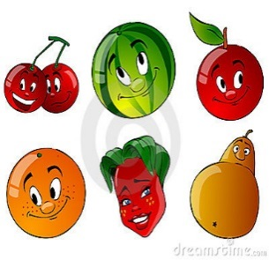
AS WELL AS OUR USUAL MENU WE NOW OFFER DAZZLING MEAL PACKS:

PACK 1: Pie + Popper + Popcorn $5.00
PACK 2: Chicken Burger + Popcorn + Popper $6.00
PACK 3: Hot dog + Quench + Popcorn $5.00
PACK 4: Hot Dog + Jumpy’s + Choc/Straw Milk $6.00
PACK 5: Sausage Roll + Choc/Straw Milk $5.00
PACK 6: Chicken Nuggets (6) + Popper + Jumpy’s $6.00
Pack 7: Pie + Popcorn + Choc/ Straw Milk $6.00
PACK 8: SALAD BOX & WATER $3.50
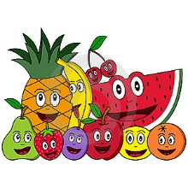
We are trying to improve our menu all the time. Thank you for your support. With your continued support we can together make a healthy and happy canteen for all children.

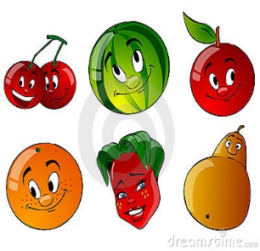

EXCURSION PACKS AVAILABLE ALSO:
A Sandwich, Piece of Fruit, popcorn & Water
$5.
Please Pre-order to ensure your child receives their pack.

CRUNCH N SIP PACKS AVAILABLE:
A Piece of fruit/ or Diced Fruit tub & Water
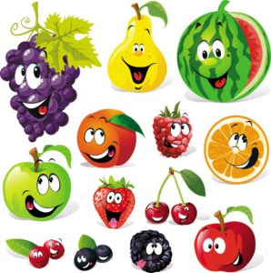
$2.

