

**Villawood North Public School**

Bligh Street, Fairfield East 2165

P 9724 1423   F 9728 2296

Email address: villawoodn-p.school@det.nsw.edu.au

Together We Live

**Dance / Fitness Program - Dance2bfit**

31.03.2025

Dear Parents and Caregivers,

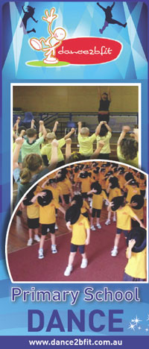

We are having the Dance2bfit Program at our school in Term 2, 2025. Dance2bfit has been developed specifically for NSW Primary Schools under the PDHPE syllabus. Each class will learn a professionally choreographed dance routine suitable for their age and ability level as well as develop their confidence and skill in this area of the Arts.

The choreography is taught weekly by Dance2bfit instructors, under the supervision of class teachers. The program will prepare our students for the Whole School Concert at the end of Term 2.

The school will be covering the entire cost of the program as it is part of the curriculum. No payment or permission note is required.

Should you have any questions, do not hesitate to contact the office on 97241423.

Mrs Mizdrak and Ms Danh Ms. Wilton

Coordinators Principal